**SHIP DETECTION ON HIGH-RESOLUTION**

**REMOTE SENSING IMAGE VIA SCENE**

**USING MASK R-CNN**

**[ A18 BATCH] DOMAIN: DEEP LEARNING**

**TEAM MEMBERS:**

Dharshini A(211417104051)

Hemamalini R(211417104085)

Jayashree V(211417104090)

**GUIDE:** Mrs M.Sangeetha,M.Tech.,

# ABSTRACT

Ship detection methods based on deep learning have improved accuracy over traditional methods. The detection of inshore and offshore ships is a major task in both military and civilian fields. The dataset was trained and used to detect the presence of the ships in a given image. In the existing system, we use Deep Neural Network (DNN) and YoloV3, which reduces the accuracy due to false alarms caused by ship-like objects on land. In the proposed system, we use an end-to-end method, such as Scene Mask R-CNN, which is proposed to reduce the onshore false alarms. The scene mask extraction network (SMEN), which is a network branch for scene segmentation, is present in the detection framework. We will detect the presence of ships in the given image using Machine Learning and Deep Learning Algorithms. In our project ship identification and categorization will be done. It will categorize warship, container ship, etc. Deep Learning is a subfield of machine learning with algorithms based on artificial neural networks. We use Convolutional Neural Network in our project for training and detecting the ships in the given image. Ship detection plays a major role in marine traffics, transportation, fisheries dumping of pollutants, and illegal smuggling.

# INTRODUCTION

* Ship detection from remote sensing imagery has been a major application for maritime security. When talking about maritime security, we have to consider many things like traffic surveillance, protection against illegal fisheries, oil discharge control, and sea pollution monitoring. Automated Identification System (AIS) is very effective at monitoring ships which are legally required to install a VHF transponder but fail to detect those which are not and those which disconnect their transponder.
* Another most common approach is the CFAR-constant false rate use to detect targets with threshold with pixel’s amplitude hence it is difficult to extract features. In addition, these methods are typically dependent on the statistical distribution of sea clutter, leading to poor robustness for new SAR imagery. For extraction of ship all they need is synthetic aperture radar (SAR) images or panchromatic images as they are of high resolution. Monitoring of ships from satellite images helps in timely and periodic checking for anonymous movements in their territory region. Though in real time application it is much more complex and computation should be done considering this real time factor while detection and recognition. Remote sensing plays a very important role in monitoring ships as it operates from some distance and has a wide monitoring range. At the same time the sea surface gives better valid information than the appearance of ship.

**LITERATURE SURVEY**

## S.NO TITLE YEAR AUTHOR WORK DRAWBACKS

1. Adaptive Deconvolutional 2016, International D. Zeiler, Graham W. Taylor and We present a hierarchical model While edges only vary in Networks For Mid And Conference on Rob Fergus that learns image decompositions orientation and scale, larger-

High Level Feature Computer Vision via alternating layers of scale structures are more

Learning convolutional sparse coding and variable

max pooling.

1. Spatial Pyramid Pooling In 2015, IEEE Kaiming He, Xiangyu Zhang, Existing deep convolutional neural Convolutional layers do not

Deep Convolutional Transactions on Pattern Shaoqing Ren, and Jian Sun networks(CNNs)require a fixed- require a fixed image size and

Networks Analysis and Machine size(e.g.,224x224)input image .In can generate feature maps of For Visual Recognition Intelligence. this work ,we equip the network any sizes.

with another pooling strategy,”spatial pyramid pooling”, to eliminate the above requirement.

1. Very Deep Convolutional 2015, Karen Simonyan_ & Andrew In this work we investigate the Oceanic SAR imagery is Networks for computer Vision and Zisserman effect of the convolutional network affected by different kinds of

Large-Scale Image Pattern Recognition depth on its accuracy in the large- disturbances, such as speckle Recognition (cs.CV) scale image recognition setting., or marine discontinuity

which shows that a significant effects due to random improvement on the prior-art changes in bathymetry and configurations can be achieved by wind currents. pushing the depth to 16-19 weight layers.

1. U-Net: Convolutional 2015, International Olaf Ronneberger, Philipp Fischer, In this paper, we present a network Larger patches require more

Networks for Conference on Medical and Thomas Brox and training strategy that relies on max-pooling layers that

Biomedical Image Image Computing and the strong use of data augmentation reduce the localization 5 Segmentation Computer-Assisted to use the available annotated accuracy.

## S.NO TITLE YEAR AUTHOR WORK DRAWBACKS

1. Segnet: A Deep 2016, Vijay Badrinarayanan, Alex We present a novel and practical The maximum of all the

Convolutional Encoder- IEEE Transactions on Kendall, Roberto Cipolla deep fully convolutional neural classifier responses in this

Decoder Pattern Analysis and network architecture for semantic sub tree becomes the Architecture for Image Machine Intelligence. pixel-wise segmentation termed classification score of the

Segmentation SegNet. The up sampled maps are query image.

sparse and are then convolved with trainable filters to produce dense feature maps.

1. Fully Convolutional 2016, Proceedings of Evan Shelhamer_, Jonathan We show that convolutional Each pixel is labeled with the

Networks for Semantic the IEEE Conference Long_, and Trevor Darrell networks by themselves, trained class of its enclosing object

Segmentation on Computer Vision end-to-end , pixels-to-pixels, or region, but with

and Pattern exceed the state-of-the-art in shortcomings that this work Recognition (CVPR) semantic segmentation. addresses.

Recognition

that shares full

-

image

many of the properties of

Detection

1. Object Detection with 2019, IEEE Zhong-Qiu Zhao, Peng Zheng,, Their performance easily

Deep Learning Transactions on Neural Shou-tao Xu, and Xindong Wu stagnates by constructing complex Large variations in

Networks and Learning ensembles that combine multiple viewpoints, poses, occlusions Systems low-level image features with and lighting conditions, it’s

high-level context from object difficult to perfectly detectors and scene classifiers. accomplish object detection. Finally, several promising directions and tasks are provided to serve as guidelines for future work in both object detection and relevant neural network-based learning systems.

1. Faster R-CNN: Towards 2015,Computer Vision Shaoqing Ren_ Kaiming He Ross In this work, we introduce a 6

Real-Time Object and Pattern Girshick Jian Sun Region Proposal Network (RPN) A novel dataset that combines

**S.NO**

**TITLE**

**YEAR**

**AUTHOR**

**WORK**

**DRAWBACKS**

9

10

Deep Residual

Learning for Image

Recognition

Selective Search for

Object Recognition

2016

, IEEE Conference on

Computer Vision and

Pattern Recognition

(

CVPR

)

, International

2011

Conference on Computer

Vision

Kaiming

He

Xiangyu

Zhang

Shaoqing

Ren Jian Sun

Koen E. A. van de

Sande

, Jasper

R. R.

Uijlings

, Theo

Gevers

,

Arnold W. M.

Smeulders

Deeper neural networks are more

difficult to train. We explicitly

reformulate the layers as learning

residual functions with reference

to the layer inputs, instead of

learning unreferenced functions.

For object recognition, the

current state

-

of

-

the

-

art is based

on exhaustive search. Our

method is class

-

independent and

is shown to cover 96.7% of all

objects in the Pascal VOC 2007

test set using only 1,536 locations

per image.

Up to now, ship detection in

optical satellite images is still

challenging with respect to

clouds, waves, wake clutters,

and the variability of ship

sizes.

Existing methods for general

object detection cannot be

applied to solve this problem

effectively.

Their relationship and

contributions are extensively

investigated and evaluated

# PROBLEM STATEMENT

* Ship detection and classification based on optical remote sensing images raise considerable attention in the sea surface remote sensing field. Basic feature extraction strategies and algorithms are analyzed associated with their performance and application in ship detection and classification. Based on the analysis, the remaining problems and future development trends are provided for ship detection and classification methods based on optical remote sensing images.
* Ship detection is a crucial application for global monitoring for environment and security. It permits to monitor traffic, fisheries, and to associate ships with oil discharge. Typical discriminate parameters are ship lengths, speed, and radar cross section. A basic classification strategy is proposed.
* In consideration of several challenges mentioned above, we believe that a practical ship detection Method should meet two requirements: it should be robust to the interference of the high variability of targets and background clutter such as waves, islands, clouds, and so forth. Of equal importance, with the purpose of the engineering applications, it should have lower calculation complexity and satisfy the requirements of real-time processing.

# TECHNOLOGY STACK

|  |  |
| --- | --- |
| **Software :** |  |
| • Operating System | : Windows 7 and above (64-bit). |
| • Software | :Anaconda 3.7 (Jupiter Notebook IDE) |
| • Python **Hardware:** | : 3.7 |
| • Hard disk | : 500 GB and above. |
| • Processor | : i3 and above. |
| • Ram | : 4GB and above. |

**SYSTEM ARCHITECTURE**

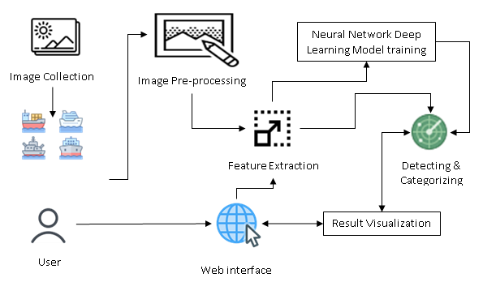

**System Design – Use Case Diagram**

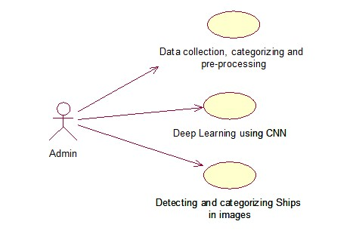

**System Design – Activity Diagram**

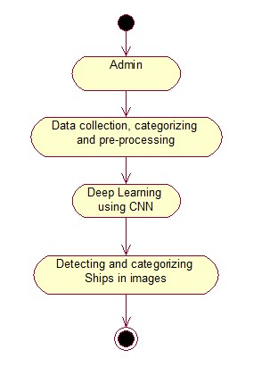

**System Design – Collabration Diagram**

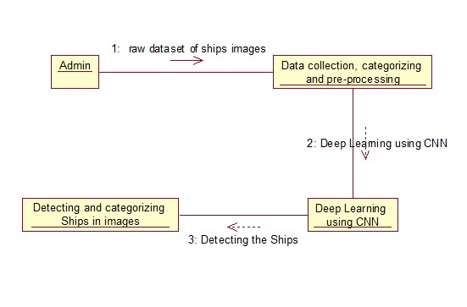

**System Design –Sequence Diagram**

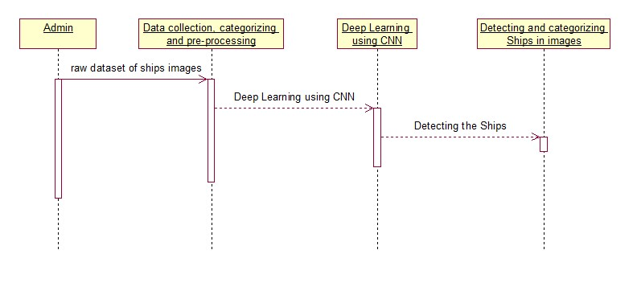

**System Design – Data Flow Diagram**

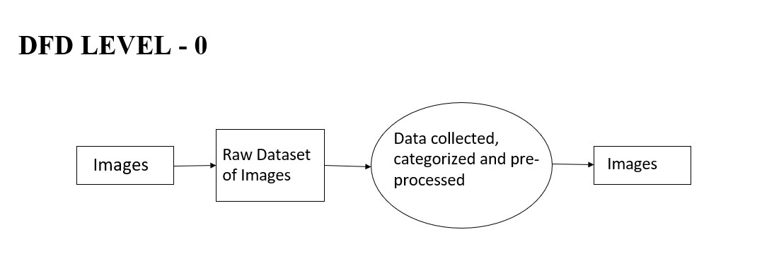

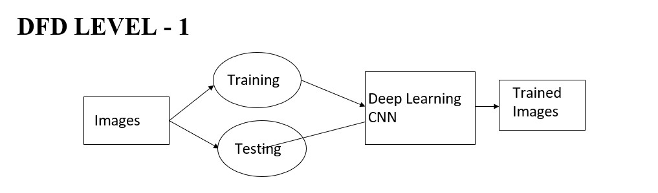

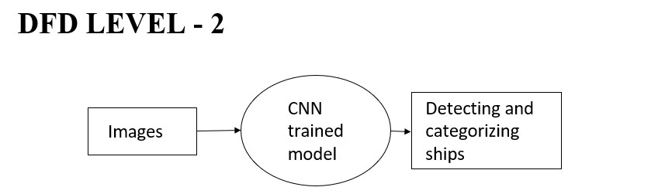

# MODULES

* Data collection, categorizing and pre-processing
* Deep Learning using CNN
* Detecting and categorizing Ships in images.

## Data collection, categorizing and pre-processing

* A High-Resolution Remote Sensing Image dataset was collected from data.gov. Many images do not contain ships, and those that do may contain multiple ships. Ships within and across images may differ in size (sometimes significantly) and be located in open sea, at docks, marinas, etc.
* A raw dataset was collected with type of ships and images for each type of ships. Since we did not have more number of ships images classified based on the categories, we use python to web crawl images from internet. The web scraped images were stored in different folders. For this project we were using four categories. We have downloaded ship images for the following categories, Accommodation, Container, War and Cruise. Python with vast text processing and networking libraries is the best tool to write one-off web scrapper.

### Deep Learning using CNN

Deep Learning is a subfield of machine learning concerned with algorithms inspired by the structure and function of the brain called artificial neural networks. Deep learning is a class of machine learning algorithms that use a cascade of multiple layers of nonlinear processing units for feature extraction and transformation. Each successive layer uses the output from the previous layer as input. We use convolutional Neural Network in our project for training and detecting the ships in the given image. We use multilayer neural network and each layer output is given as input to the

next layer.

## The Convolution Algorithm

* The convolution is a kind of product operation of a filter — also called a kernel — with a matrix of image to extract from it some pre-determined characteristics. Literally-speaking, we use a convolution filter to “filter” the image to and display only what really matter to us. The considered image is a matrix, the filters used are also matrices, generally 3x3 or 5x5. Let’s see how convolution works with the following kernel,

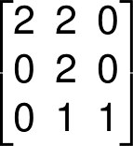

* The 6x6px matrix represents an image. At the beginning, the convolution kernel, here the 3x3 matrix is positioned on the topleft corner of the matrix image, the kernel then covers a part of this matrix image, we then make a product element by element (element-wise) of the two overlapping blocks we eventually sum these products and the final result corresponds to a pixel of the output image.

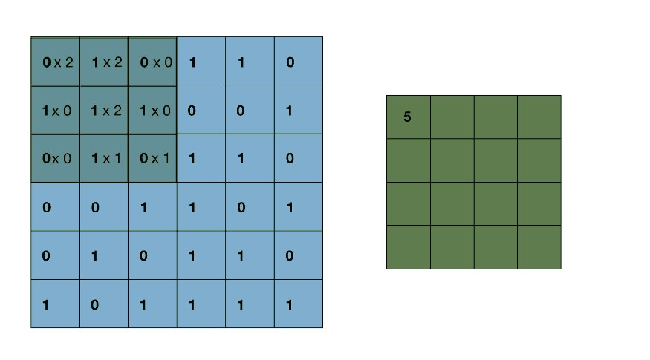

* Then, we move the convolution kernel from horizontally to the right by one pixel, we make a new element-wise product then added up to get a new coefficient of the output image.
* Once at the end of a line, the kernel makes a vertical stride down and starts again from the left, we iterate likewise until the kernel has covered all the matrix image. It is important to note that the kernel always remains on the initial matrix, without overflowing.
* For sure, we cannot use any filter, the coefficients of our kernel will depend on the features we want the filter to highlight.

Let’s see the result of a convolution with some well-known filters.

**Detecting and categorizing Ships in images**

* In this work required to locate ships in images, and put an aligned bounding box segment around the ships you

locate.

* The CNN trained model is used to detect the availability and the category of the ship in the given image. When the user inputs the images to for detection, the prediction method in the trained model is used to detect the presence of the ship, and also the category of the ship. A new image file is created with the category written on top of the actual image.

# Mask-RCNN

* Mask RCNN is a deep neural network aimed to solve instance segmentation problem in machine learning or computer

vision

* Mask R-CNN uses anchor boxes to detect multiple objects, objects of different scales, and overlapping objects in an image. This improves the speed and efficiency for object detection. Anchor boxes are a set of predefined bounding boxes of a certain height and width.
* Mask R-CNN is selected for this project because it can generate high-quality segmentation mask for each object. Its mask prediction branche is added in parallel to Faster R-CNN's bounding box and image class prediction.

**TEST CASES AND REPORT**

**DETECTION OF SHIPS**

|  |  |  |  |  |
| --- | --- | --- | --- | --- |
| S.NO | INPUT | EXPECTED OUTPUT | ACTUAL OUTPUT | RESULT |
| 1 |  |  |  | PASSED |
| 2 |  |  |  | PASSED  23 |

**CATEGORIZATION OF SHIPS**

|  |  |  |  |  |
| --- | --- | --- | --- | --- |
| S.NO | INPUT | EXPECTED OUTPUT | ACTUAL OUTPUT | RESULT |
| 1 |  |  |  | PASSED |
| 2 |  |  |  | PASSED |

# PERFORMANCE ANALYSIS

Mask R-CNN achieves 92.3% of accuracy rate by solving imbalanced problems, which yields improvement over Yolo v3 and Rotational Libra R-CNN. It achieves an detection rate of 30.3 frames. Our method has the best accuracy which is higher than R2CNN by 7.35%. A key reason is that our method achieves more discriminative features and better convergence. In addition, for the arbitrarily oriented slim ship, the rotational region detection branch is designed to eliminate the redundant background.

## SCREENSHOTS-DATASETS

**STEP 1:**



**STEP 2:**

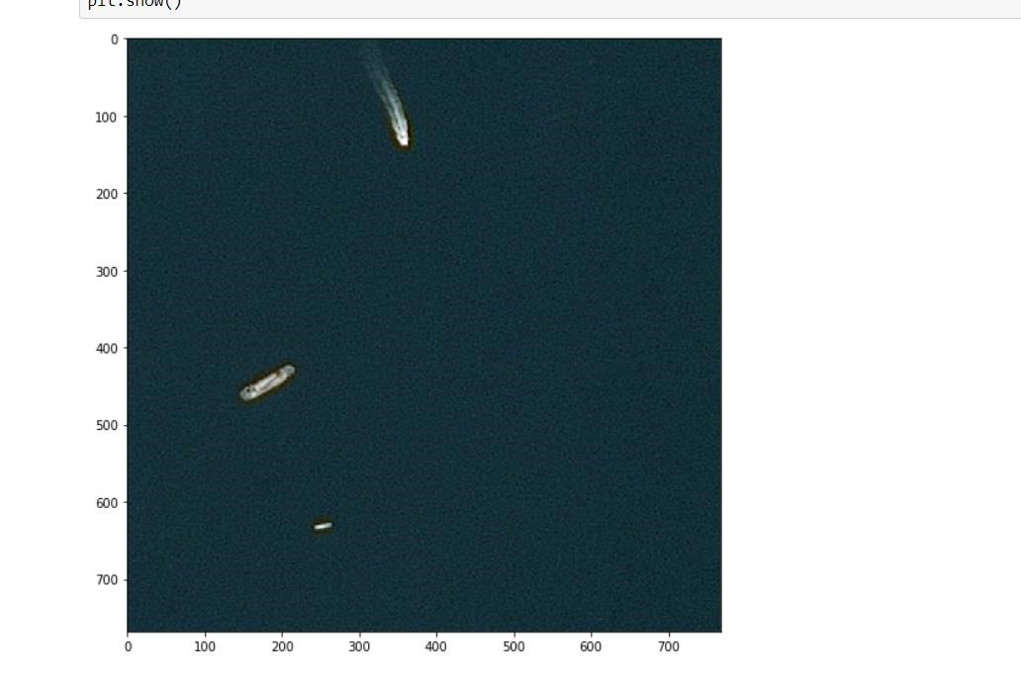

**STEP 3:**

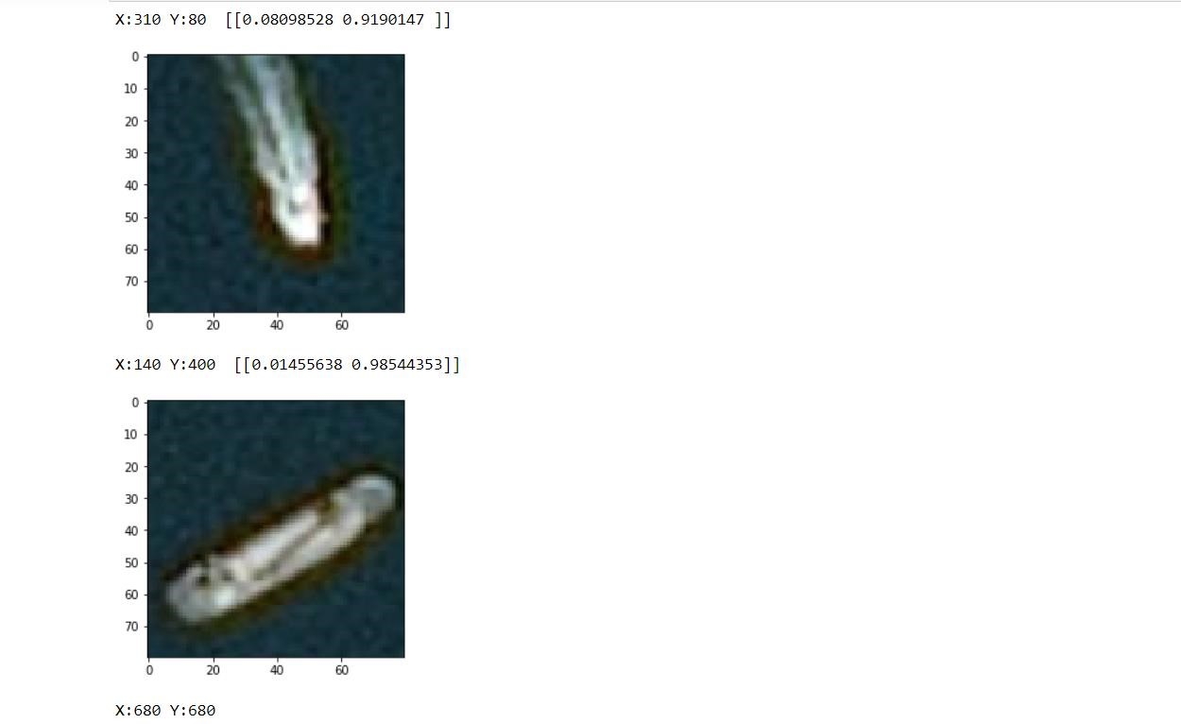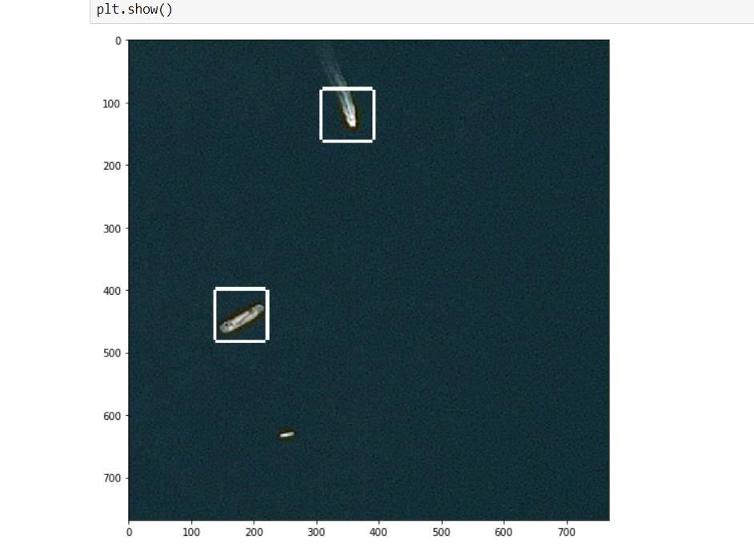

**STEP 4:**

**STEP 5:**

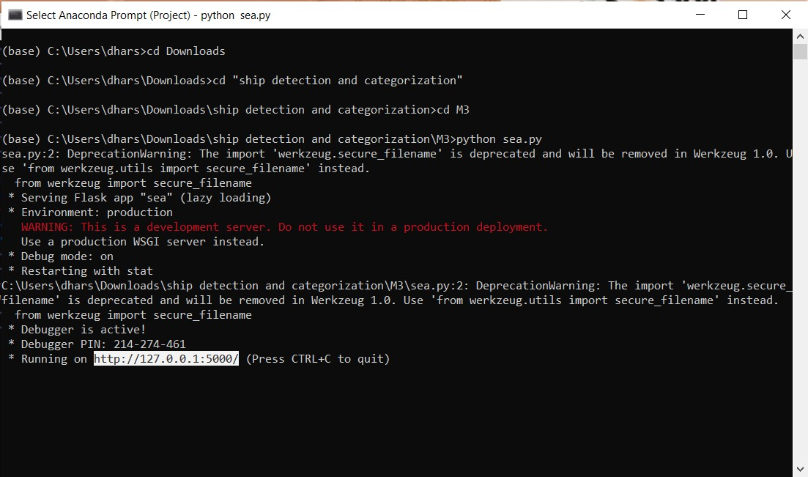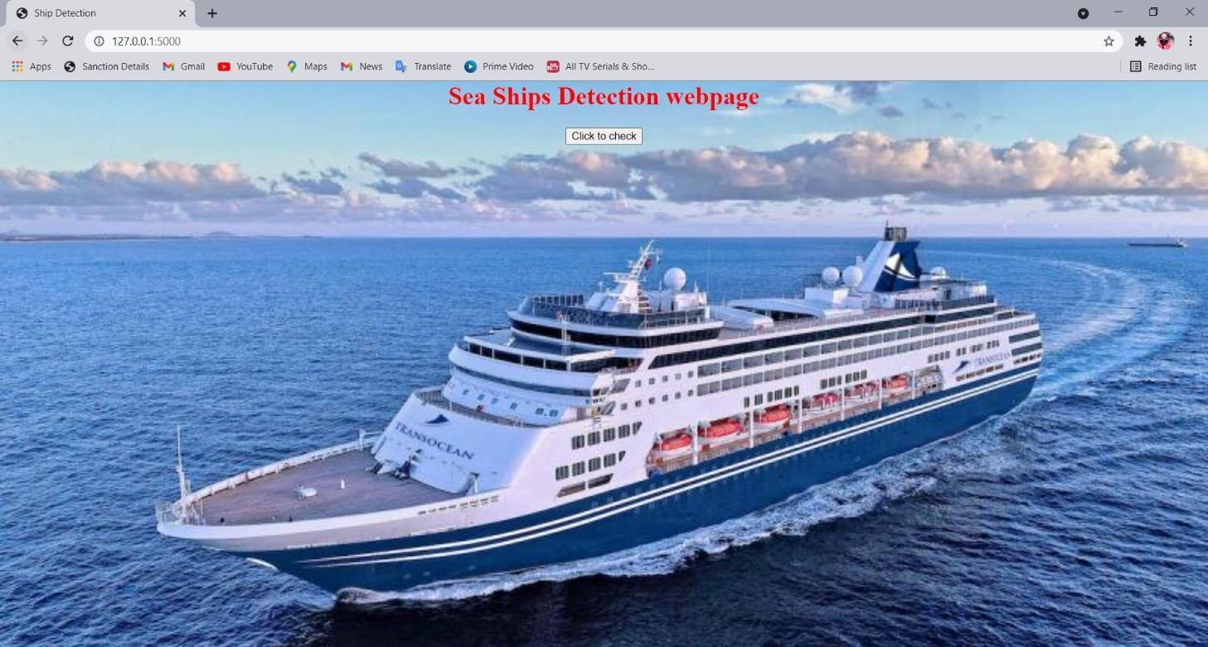

**STEP 6:**

**STEP 7:**

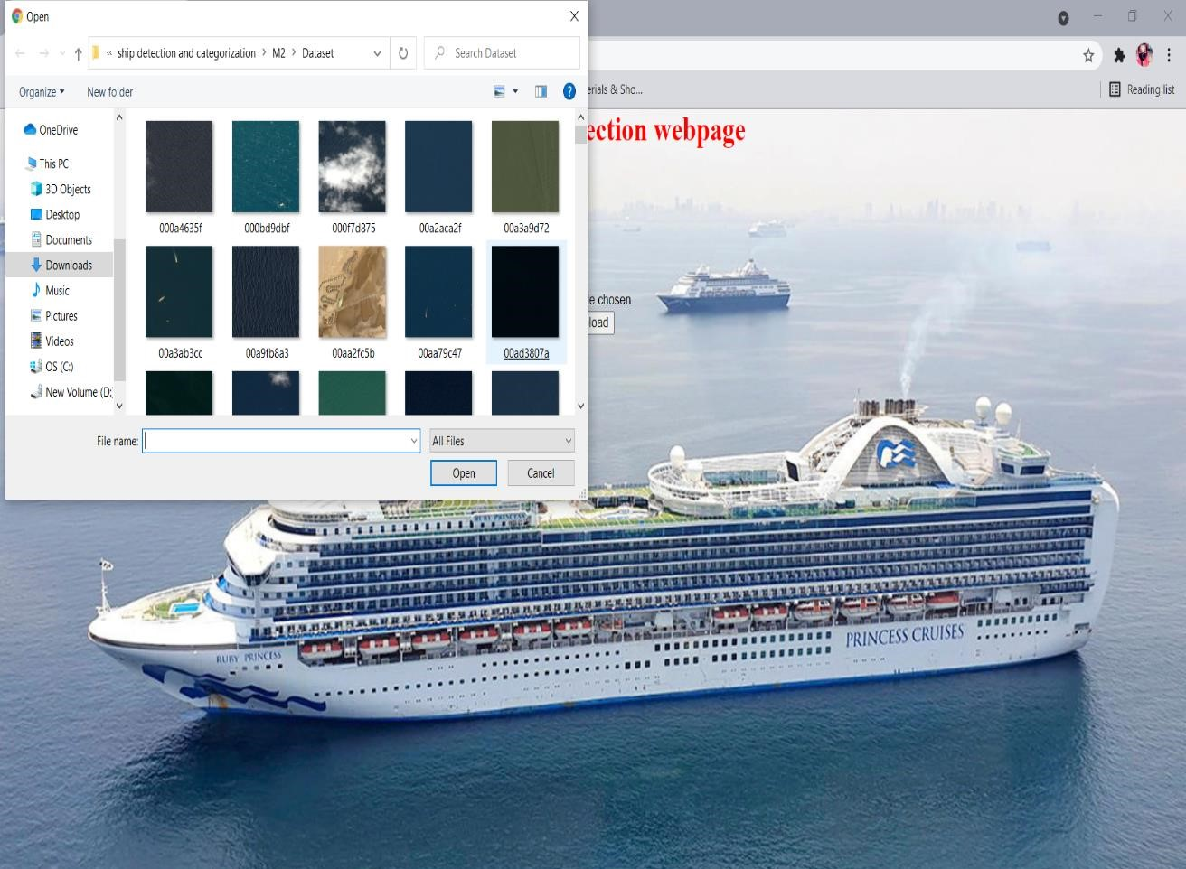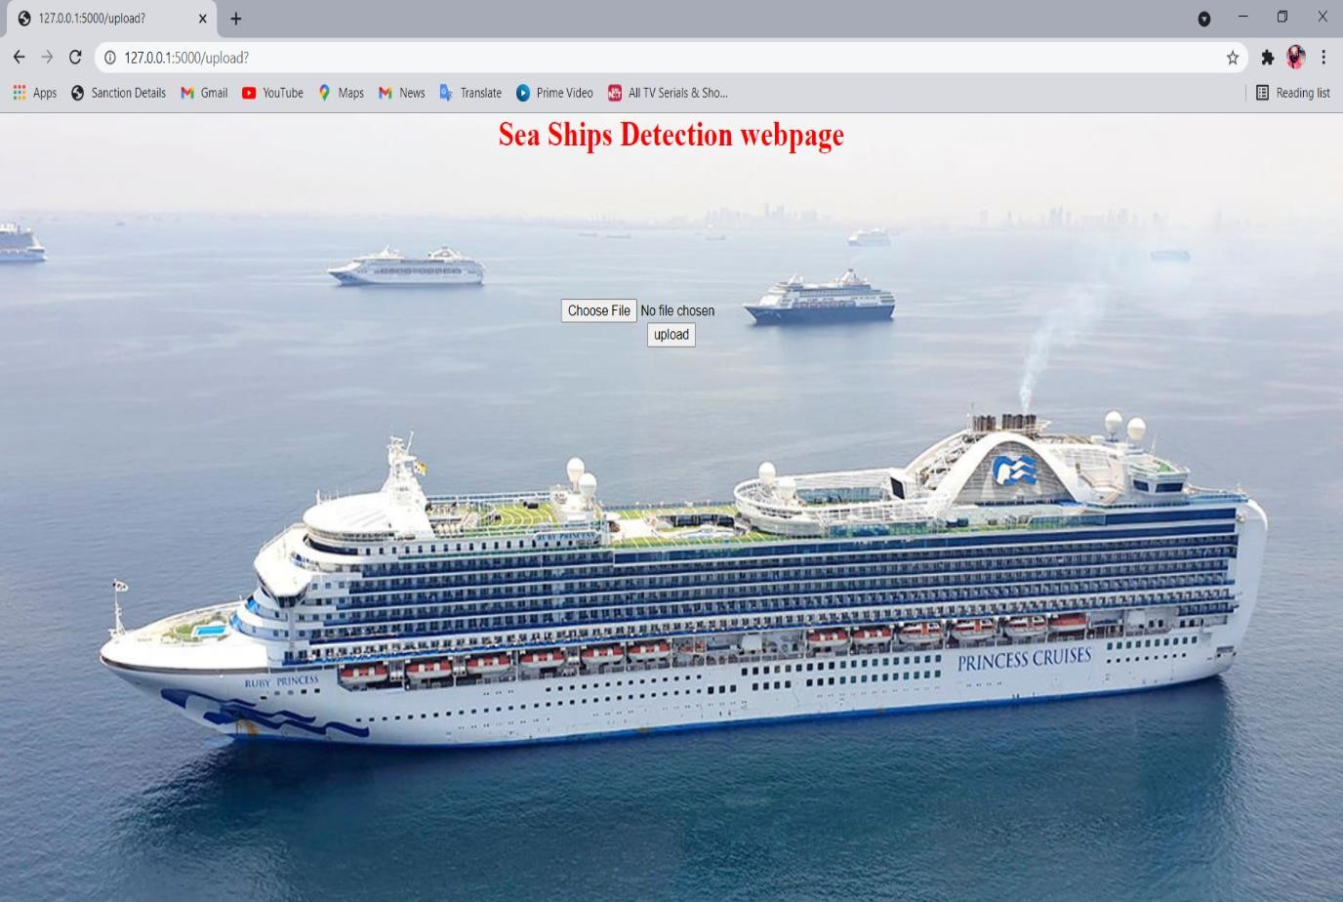 **STEP 8:**

**STEP 9:**

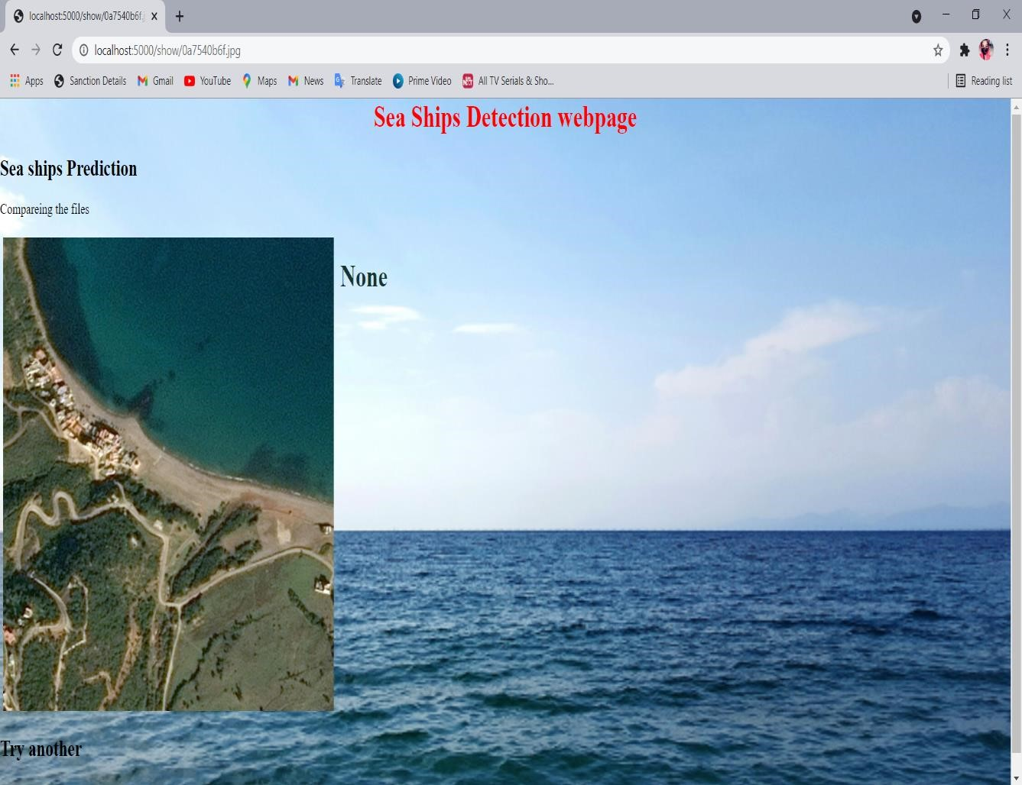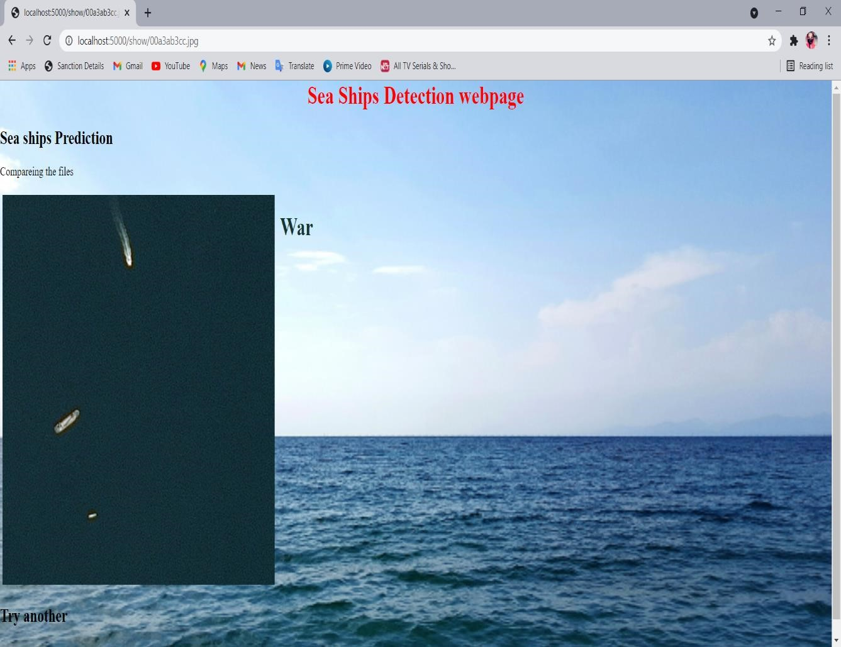 **STEP 10:**

**STEP 11:**

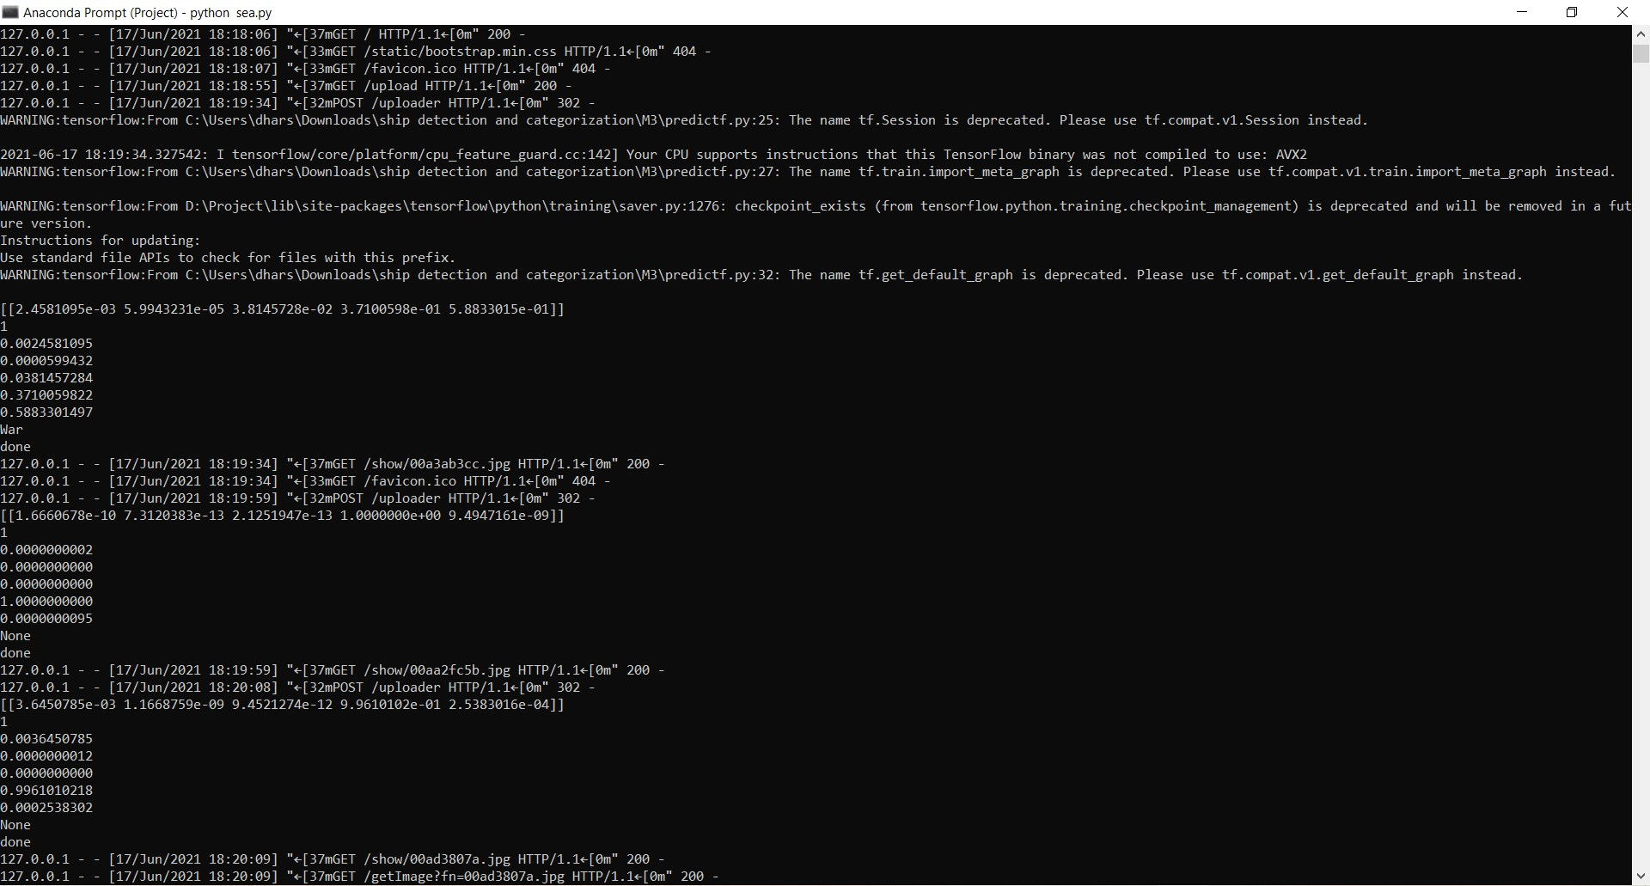

### CONCLUSION AND FUTURE ENHANCEMENT

In this article, we investigate the constraints of thick dissemination and various sizes. Therefore, we propose Mask R-CNN, a mask R-CNN for transport discovery. BFP module and IOU-BS module are presented with the inspiration of separating discriminative highlights to conquer the effect of various sizes. Moreover, the rotational district location with adjusted L1 misfortune is at long last proposed to be hearty against the effect of thick appropriation. Our strategy can acquire reliable upgrades in exactness and perception. What's more, broad tests on the DOTA show that the proposed technique can acquire 3.43% than R2CNN and 4.09% than mask R-CNN. Alongside transport recognizable proof, we propose boat characterization framework dependent on the structure and class of boats. The proposed framework would distinguish a boat, yet would likewise characterize it as a warship, load boat and journey transport. It would decrease the quantity of bogus cautions on the coast. We are proposing alongside transport location, a boat order dependent on the kind and classification of the boats. The proposed framework won't just distinguish a transport yet additionally arrange as war transport, holder transport and so on It will decrease the on shore bogus alerts.

## REFERENCE

1. D. Zeiler, Graham W. Taylor and Rob Fergus,”Adaptive Deconvolutional Networks For Mid And High Level Feature,”International Conference on Computer Vision, 2016
2. Kaiming He, Xiangyu Zhang, Shaoqing Ren, and Jian Sun,”Spatial Pyramid Pooling In Deep Convolutional Networks For Visual Recognition,”IEEE Transactions on Pattern Analysis and Machine Intelligence, 23 April 2015
3. Karen Simonyan & Andrew Zisserman,” Very Deep Convolutional Networks for Large-Scale Image Recognition,”

Computer Vision and Pattern Recognition (cs.CV) ,2015

1. Olaf Ronneberger, Philipp Fischer, and Thomas Brox,” U-Net: Convolutional Networks for Biomedical Image

Segmentation,” International Conference on Medical Image Computing and Computer-Assisted Intervention,18 May 2015

1. Vijay Badrinarayanan, Alex Kendall, Roberto Cipolla,” Segnet: A Deep Convolutional Encoder-Decoder

Architecture for Image Segmentation,” IEEE Transactions on Pattern Analysis and Machine Intelligence, 10 Oct 2016

1. Evan Shelhamer_, Jonathan Long_, and Trevor Darrell” Fully Convolutional Networks for Semantic Segmentation,” Proceedings of the IEEE Conference on Computer Vision and Pattern Recognition (CVPR),”20

May 2016

1. Zhong-Qiu Zhao, Peng Zheng, Shou-tao Xu, and Xindong Wu ”Object Detection with Deep Learning,” IEEE Transactions on Neural Networks and Learning Systems,16 Apr 2019
2. Shaoqing Ren_ Kaiming He Ross Girshick Jian Sun,’’Faster R-CNN: Towards Real-Time Object Detection

With Region Proposal Networks,’’Computer Vision and Pattern Recognition,2019

1. Kaiming He Xiangyu Zhang Shaoqing Ren Jian Sun,’’Deep Residual Learning for Image Recognition,”IEEE Conference on Computer Vision and Pattern Recognition (CVPR),2015
2. Koen E. A. van de Sande, Jasper R. R. Uijlings, Theo Gevers, Arnold W. M. Smeulders,’’Selective Searchfor

Object Recognition,’’International Conference on Computer Vision,2012

# PUBLICATION DETAILS

* This project was published as a paper in Journal of Emerging Technologies and Innovative Research on

25.04.2021 by Hemamalini R, Dharshini A, Jayashree V.

* **Published issue**: ISSN:2349-5162,Vol 8 issue 4, April 2021
* **DOI Details**: https://www.jetir.org/view?paper=JETIRES06024